**Sponsor: Dr. Badri Roysam (Makerspace)**

University of Houston

Dept. of Electrical & Computer Engineering

N308 Engineering Bldg 1

4726 Calhoun Rd

Houston, TX 77204-4005

Phone: 713-743-4435

Sent to: [broysam@central.uh.edu](mailto:broysam@central.uh.edu)

Cc: [litvinov@uh.edu](mailto:litvinov@uh.edu)

March 5th, 2019

Greetings Dr. Roysam,

We want to thank you again for approving our Makerspace and Team 16 senior design project, Knuckles, the assistive robotic arm to be exhibited at the 2019 ECEDHA Conference in Tucson, Arizona.

We are about to finish the second prototype of the robot arm. We are able to control the motors using Arduino and Rviz. The robot is almost fully built. We are currently tuning the motion of motors. We installed the camera mount on the physical arm. We still need to set the tactile pads up on the gripper. We improved the April Tags detection; the arm follows the April Tags and responds to text commands. We connected the Intel Voice Enabling Development Kit an Raspberry Pi3+ to process speech to text. We are still developing the GUI. These next upcoming months, we will focus on connecting all the modules of the project to accomplish an automated and autonomous system.

Overall, we are on track and are confident on meeting our deliverables.

We are extremely grateful for your continued support of our research. If you have any questions or concerns, please feel free to contact us.

Sincerely,

Team 16

Andrew Blanchard (Team Leader), Matthew van Zuilekom, Rym Benchaabane, Paola Hernandez

# Team 16

# Knuckles, Assistive Robotic Arm

# Sponsor: Dr. Badri Roysam (Makerspace)

# Facilitator: Dr. Dmitri Litvinov

# Tuesday, March 11th 2019

# Report II

# Andrew Blanchard (Team Leader), Matthew van Zuilekom, Paola Hernandez, Rym Benchaabane

# 

# 

# 

**Purpose and Need**

Knuckles is an assistive robotic arm that will hand the user requested objects and tools through voice command. It will serve as a convenient assistant that will increase the user’s productivity and decrease the risk of dexterity incidents. The problem is that multitasking causes a lack of focus on a task which results to a waste time, money, and can also lead to serious injury. What is needed is a solution that allows the user to continue with their task without distractions, and can assist the user as needed. The extra hand will allow one to focus on the work without having to get up and grab another tool, which saves one time and effort in completing the current task.

**Overview Diagram and Background**

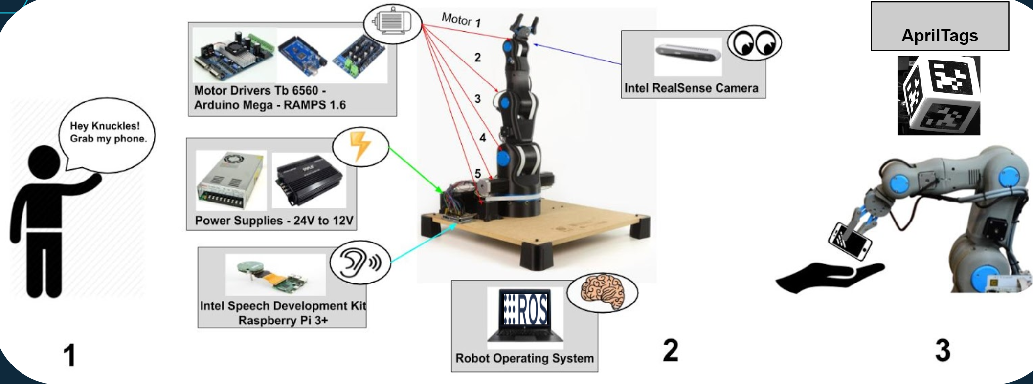

**Figure 1. Overview diagram of Knuckles functionalities**

Knuckles will be able to respond to voice commands and retrieve requested objects for the user. To accomplish this, we will connect a microphone to a RaspBerry Pi3+ which will start listening for a voice command once the user has said “Hey, Knuckles!” Voice commands will be converted to text using the Amazon Alexa Voice Service, to be interpreted by ROS on a main computer, which the RaspBerry Pi3+ is also connected. From there, the main computer will connect to an Arduino MEGA & RAMPS 1.6 combination, which is connected to the motors used to control the arm. An Intel RealSense camera will be attached to the gripper of the robot arm, which will be used to locate the requested object. An AprilTag will on each requestable object, which is what the camera will be looking for.

In today’s society, people are rushed and tend to multitask. According to research from the scientific journal, *Current Biology[1]*, shifting focus and attempting to multitask reduces productivity by around 40%. *SMF Mutual Insurance* adds that multitasking can lead to dexterity incidents while performing hands-on work.[2]

The problem is that multitasking causes a lack of focus on a task which results to a waste time, money, and can also lead to serious injury. What is needed is a solution that allows the user to continue with their task without distractions, and can assist the user as needed. The extra hand will allow one to focus on the work without having to get up and grab another tool, which saves one time and effort in completing the current task. Figure 1 represents Knuckles’ ability to respond to voice commands and hand the requested object to the user.

Our device will be used by users doing hands-on work who are unable to step away from their work, or users with disabilities. It can be operated by most in the general public, as the method to control it will simply be voice commands, which most people are capable of. The user will need minimal expertise, as they will need to know to say “Hey, Knuckles!” to have the arm start listening for voice commands, and they will need to know how to structure the command.

**Target Objectives and Goal Analysis**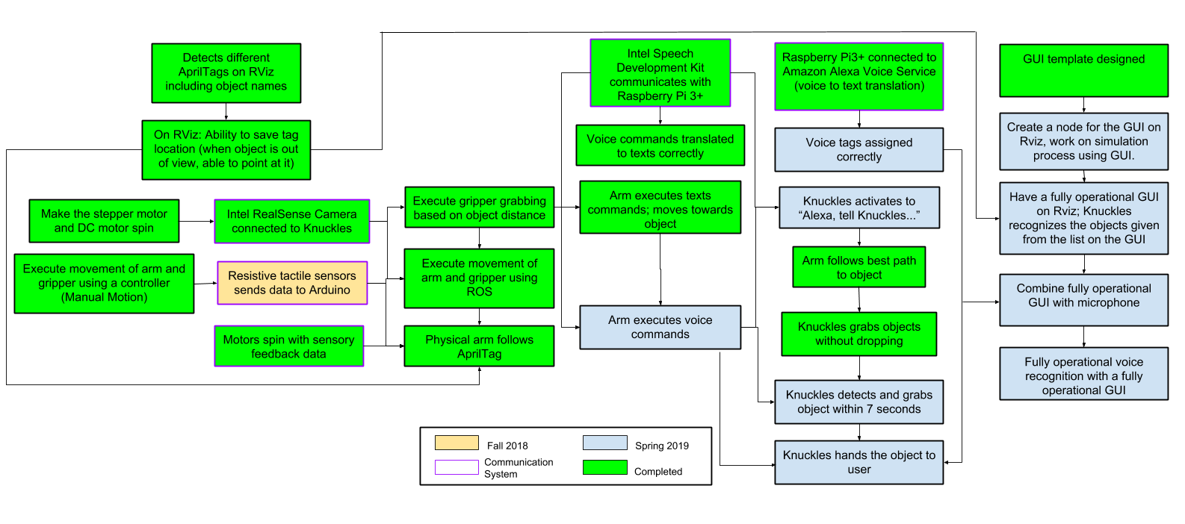

**Figure 2. The testing and goals diagram**

We have almost completed our tasks for the fall semester, as we encountered unforseen mechanical issues, leading us to develop a second prototype. We have the resistive tactile pads in possession, but still need to program the Arduino to respond to the tactile pads. We have acquired the Intel Speech Development Kit and are working with it using the Raspberry Pi and working to have it work with ROS. We replaced the 3D printed pulleys used on the physical arm with metal pulleys, improving the mobility of the physical arm The physical arm responds to the Apriltag when it’s seen in the RealSense camera, and will change its position until the tag is in the center of the image, which is when the physical arm saves its current pose. Using a text command of the object name (which is represented by the Apriltag), Knuckles is able to recall the pose it originally saved for that specific Apriltag, and return to that saved pose. Our group has also worked on the transition of text commands to voice commands, with the help of a GUI. The GUI has been designed using QT4Designer, which shows a menu of options of actions and objects Knuckles can interact with.

**Design Considerations**

**Figure 3. Design diagram and interactions between parts of the project**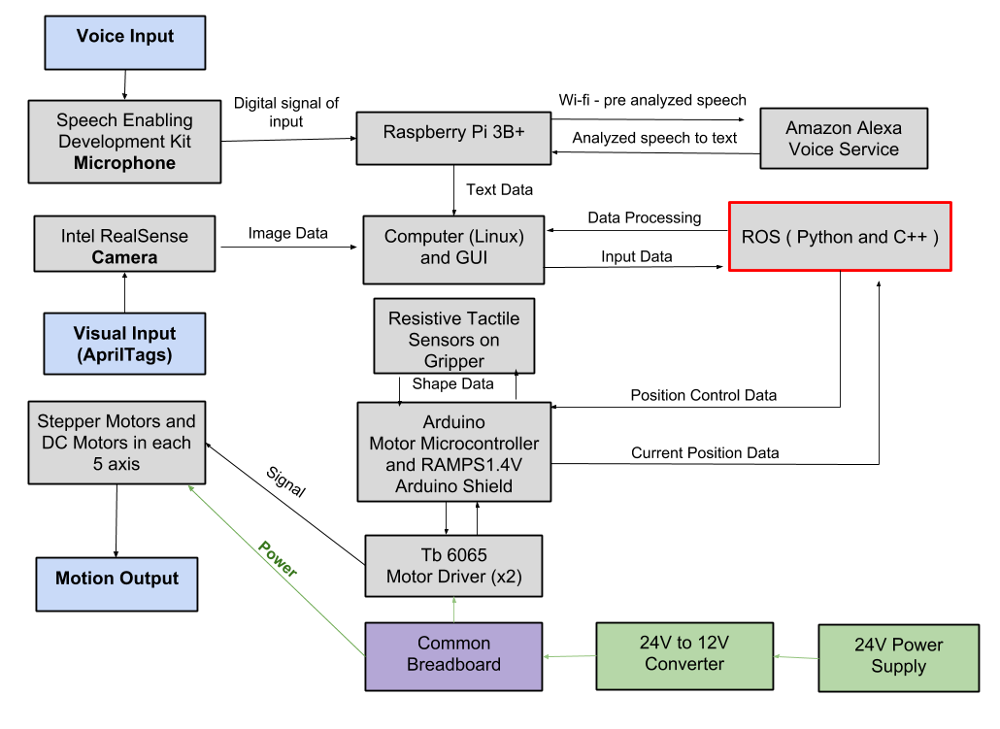

Initially, we were planning to use a 3D object detection program using the depth camera and a point cloud. However, with the inclusion of AprilTags, we can simply use the tags to get the object position in the received image, and also calculate the distance of the gripper to the tag, which was the purpose of the 3D object detection program. Thus, for the Spring semester deliverables, we will completely finish building the second prototype arm and fix any movement complications, such as a pulley slipping on a motor shaft. The arm will be able to use AprilTags to receive and deliver an object to the user. We have decided to use an Intel Speech Enabling Developer Kit as our omni-directional microphone to process speech to text. Knuckles will be able to recognize and pick up 8 objects. The reason why we have a 24V to 12V converter is because we have two NEMA 17 motors that can handle 24V. We quickly realized after testing the motors that the steppers motors work fine with 12V. Every other hardware device working with the motors require at least 12V.

**Design Constraints**

Our main design constraint is the time allotted to develop a gripper that’s capable of grabbing a larger range of objects. In addition, due to the strength of our motors, we are only able to lift a limited weight, which is listed in our specifications.

**Deliverables and Test Plan**

**Table 1: Deliverables Progress and Test Plan**

|  |  |  |  |  |
| --- | --- | --- | --- | --- |
| **Goal Status** | **Goal Description** | **Goal Modifications** | **Test Plan** | **Issues** |
| **Completed** | This allows us to confirm the arm is moving correctly and free, before applying software to it. The mechanical properties of Knuckles are divided into two components, the arm and the gripper. | None | **Test the mobility of the robot:**  Verify the arm and gripper motion with a controller. This arm uses seven motors: six to control the movement of the arm, and one to control the gripper. The controller will be able to control each of these motors individually by changing the polarity and magnitude of the voltage across each of the motors. Two of the six motors used to control the arm will control the same movement at the base of the gripper, so the controller will have to control those two motors at the same time as well | We had a significant delay ordering the necessary parts as we were doing it through Makerspace, which caused the construction of the arm to be delayed. |
| **Completed** | The goal was to have the arm properly communicating with ROS, and be able to control the entire arm using this software.  We are connecting the arm’s joints with a total of 6 stepper motors (2 for the base). These motors will be processed by ROS and controlled by Arduino. The Arduino has a add-on motor shield RAMPS1.4V. The TB6560 is the motor driver that is going to be directly wired to the motors and RAMPS1.4V. The RAMPS1.4V is powered by a 24V to 12V converter and this converter is connected to a 24V power supply. We have a breadboard as a center of power connections. | None | **Test robot connection to ROS:**  Request the robot to position itself in straight up, straight out,  and in reaching motions. The test will be successful if these basic movements are shown in both the simulation and the physical arm. | None |
| **Completed** | This is a major part of the project. Rviz is able to visualize as many tags as we can fit in the camera view, and is able to remember the object position once it has left the camera view. It provides the object translation/location in the camera view, the orientation of the object, and the object distance from the camera. The visual processing for Knuckles is handled using RViz and AprilTags. Knuckles will utilize the Intel RealSense Depth Camera D435. | We decided to use AprilTags instead to simplify our project. AprilTags allows our camera to easily locate an object in the room, and provides the position of the object in the camera view and also allows us to calculate the distance away from the object. RViz is our 3D visualization application for ROS that will work with the Intel Camera. | **Test object recognition with AprilTags:**  Validate the simulation can recognize multiple objects at the same time. We will verify that different frame will surround the different visible objects without naming them yet. | We initially planned to use OpenCV & TensorFlow for this. However, due to complications using a non-ROS program and trying to have it communicate with ROS |
| **Completed** | AprilTags are able to accomplish this much more easily, without having to create a point cloud of the entire environment. We can simply find the tag position in the environment. Instead, Rviz will map the specific location of the AprilTags, rather than mapping the entire environment. | None | **Test the ability of the robot to map the environment:**  Compare map data representation to that of the workspace of the robot. Through this we we test the object localization, and recognize the various objects around the arm. | None |
| **Completed** | The robot is able to associate AprilTag to an object name and detect it.  The gripper should be able to grab the object. | Usage of AprilTag instead of actual objects. | **Test the object search function:**  Use text recognition to have the robot point at objects. This will serve as the initial point where the robot responds to commands. The robot should be able to properly respond to 8 objects.  **Test the object retrieval function:**  Use text recognition to retrieve an object. | None |
| **In progress** | Implement a communication system with Intel Speech Development Kit, Raspberry Pi 3+ and ROS to make Knuckles process voice commands. | None | **Tests the voice recognition:**  Compare voice commands to the text in the ROS terminal.  **Test the user search function:**  Upon voice request, have the robot find the user. | None |
| **In progress** | The gripper should be able to grab the object and return the object | None | **Test the return function:**  Have the robot drop the object as close to the user as possible.  **Test the gripper with the return:**  Have the robot wait until the user is within range and pulls on the object. | None |
| **In progress** | Make the robot react and complete task 7 seconds | None | **Test the timing of the entire process:** Our goal is for the arm to be able to locate the correct object and grab within 7 seconds. | None |
| **In progress** | Create a GUI for the user to interact with Knuckles | None | **Test the responsiveness and communication between GUI and Knuckles:**  Press a home button to have Knuckles stand straight in an initial position.  Verify text commands and all 8 object identities. | None |

**Specifications and Features**

**Table 2: Specifications and Features**

|  |  |
| --- | --- |
| **Specifications** | **Features** |
| Degrees of Freedom (DOF) Arm – Five | Powered by Mains – Yes |
| Accuracy Voice Interpretation – 70% | Integrated Microphone – Yes |
| Minimum Voltage for Motors – 12V | Integrated Camera – Yes |
| Object Detection – AprilTags | Object Detection – AprilTags |
| Object Count Library – 8 | Voice-Controlled using Alexa Voice Service – Yes |
| Responsiveness Range – 4 meters | GUI-Controlled – Yes |
| Response Time – 7 seconds | Wi-Fi required – Yes |
| Maximum Grabbing Reach – 0.7 meters |  |
| Maximum Weight Rating – 0.5 kG |  |

**Schedule and Gantt Chart**

In the Gantt charts below, the dark blue cells represent completed tasks, green cells represent a delay, and light blue cells represent in-progress tasks.

**Figure 4: Spring semester Gantt chart**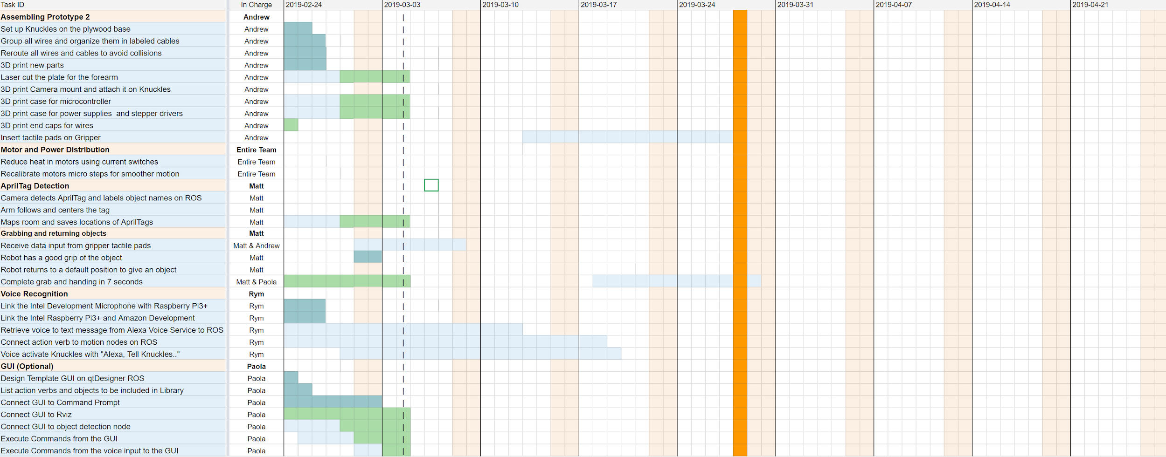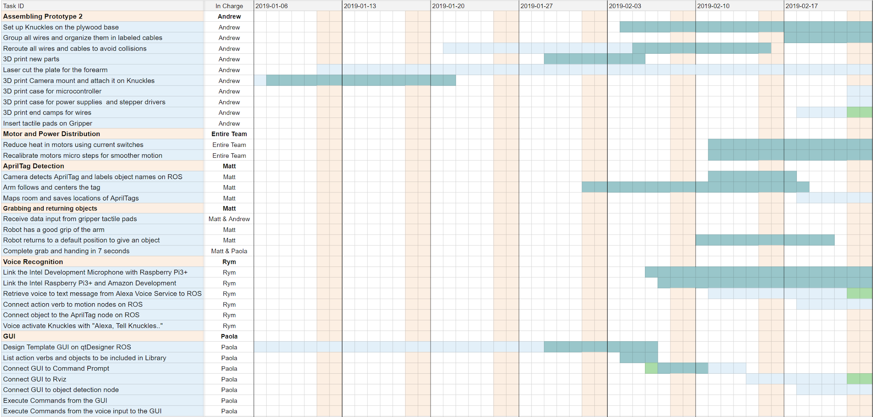

**Total Budget**

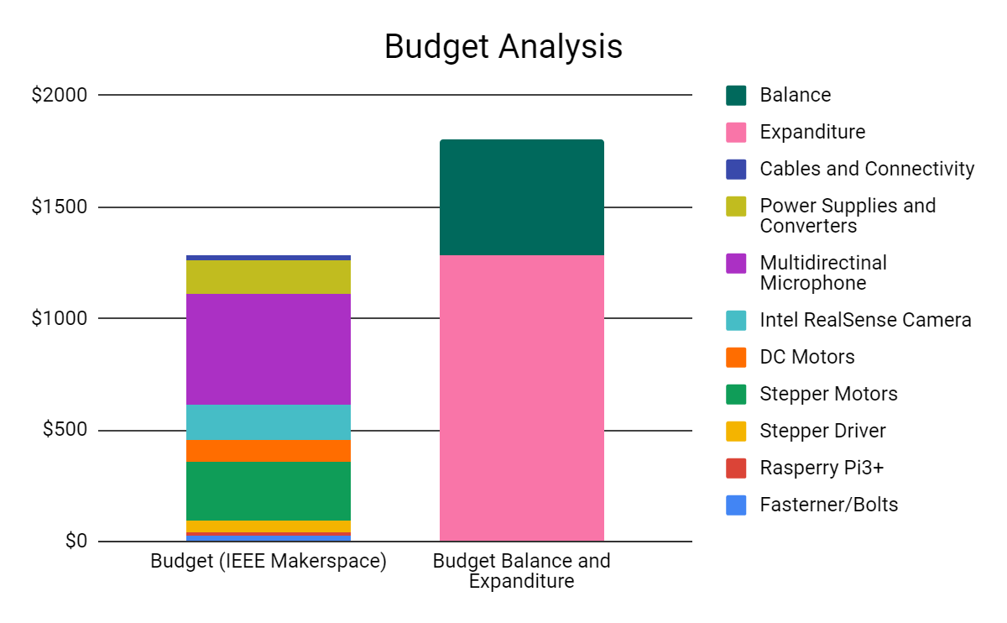

**Figure 5: Graphical representation of total budget**

We would like to thank our sponsors, IEEE Makerspace and Dr. Becker for making this project possible. All of the parts needed in order to finish constructing Knuckles have arrived, and we do not expect to make more purchases. Also, we appreciate the help of Dr. Becker, by allowing us to use his 3D printers from his research lab that has been very beneficial for our project. Overall, our total budget is $1,800, however, we have a current balance of $517, and have expended $1283, which is around 70% of our budget. Any project optimization and improvements are mainly software based rather than hardware. It will require more man hours.

**Risk Management and Mitigation**

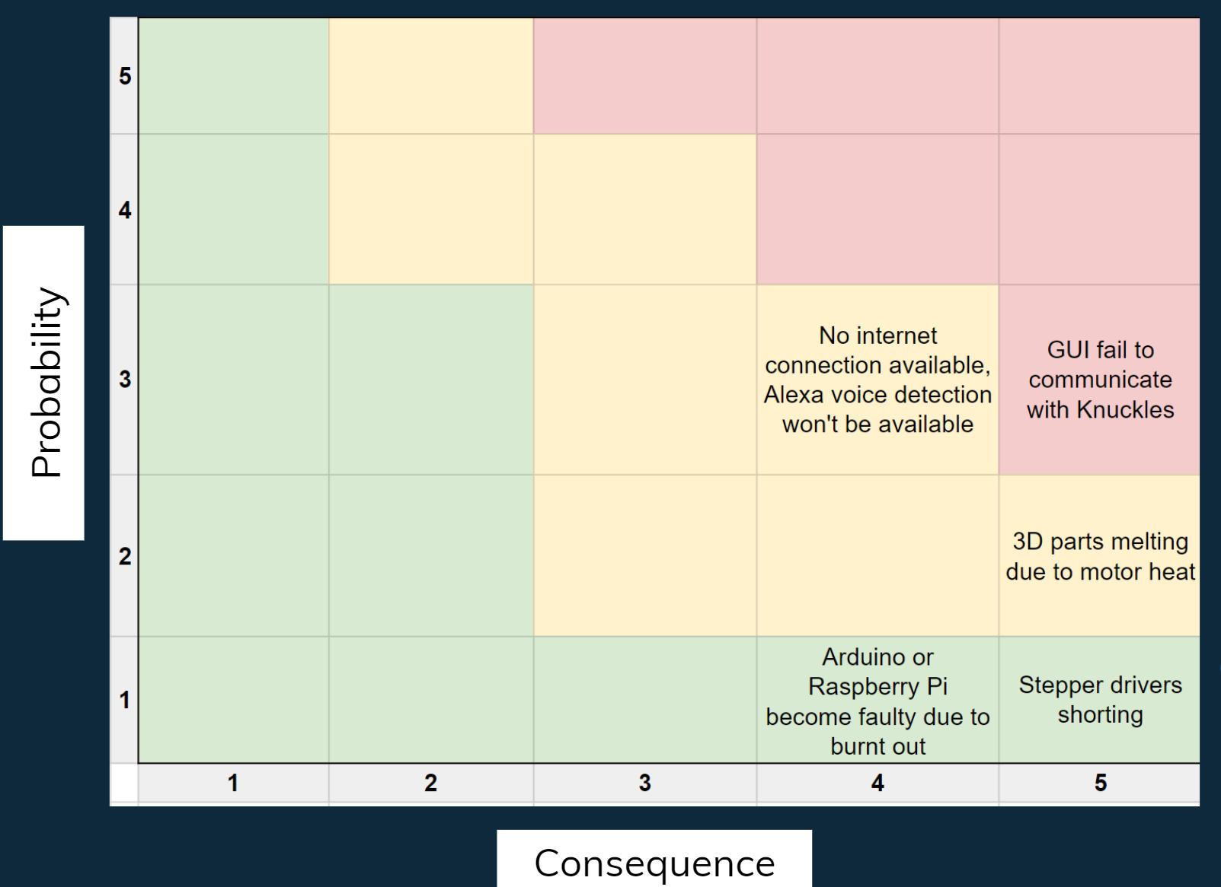

**Figure 6: Risk Matrix**

Pertaining to the risk mitigation: if the GUI fails to communicate with Knuckles, using the voice to text input method can be an option to overcome this issue. If there is no internet connection available, Alexa voice detection will be unavailable but we can overcome this obstacle by using a text input. We can always re-print melted parts in case a 3D part melts due to motor heat. Next, the stepper drivers might short but we have four extra stepper drivers as replacements. Finally, Arduino or Raspberry Pi might become faulty due to burnt out connections but thanks to Makerspace, we can get replacements for free.

**Project Summary**

Knuckles is an assistive robotic arm that will hand the user requested objects and tools through voice commands. Its purpose is to help increase the user’s productivity and decrease the risk of dexterity accidents. This project combines robotic motion and voice/object detection. Knuckles is a five axis robot with a two finger gripper. The arm will be processing a voice input from the Intel Speech Development Microphone, a visual input from the Intel RealSense Camera and a motion input from the Arduino Mega 2560. All the data will be interpreted by the Robot Operating System (ROS) installed on a computer. As for our team’s current progress, the second prototype is almost fully built. We still need to install the gripper motor, the microphone, and tactile pads on the arm. We can control the arm using a simulation in Rviz. The robot can also detect and follow AprilTags in Rviz and grab objects. Our team also started developing The Graphical User Interface (GUI) to have an easier interaction with Knuckles through voice and text commands. Our team used 70% of a 1800$ budget. We would like to thank our sponsor, Dr. Roysam, as well as our faculty advisor Dr. Becker their generous donations.

1. Gross, Michael. “Chronic stress means we’re always on the hunt”. Current Biology, https://www.cell.com/current-biology/fulltext/S0960-9822(14)00489-8
2. Boblard, Lionell. “Injured Workers.” *SFM Mutual Insurance*, [www.sfmic.com/injured-workers/](http://www.sfmic.com/injured-workers/).